To implement this assignment I have followed below steps :

1. Launched EC2 Machine, configured Security group with port no. 80 and port no. 8080 to host website.
2. Installed Java 11 (yum install java-11-amazon-corretto-javadoc.x86_64) .
3. Install apache httpd server ( yum install httpd –y ) or we can install at the time of creation of Job in Build Step.
4. Download apache tomcat server and deploy Jenkins.war in webapps .

# cd /mnt

# mkdir Servers

# wget <https://dlcdn.apache.org/tomcat/tomcat-9/v9.0.89/bin/apache-tomcat-9.0.89.zip>

# unzip apache-tomcat-9.0.89.zip

#chmod –R 777 apache-tomcat-9.0.89 ---give permission as excutable file is present

# cd apache-tomcat-9.0.89

# cd Webapps/

#wget <https://get.jenkins.io/war-stable/latest/jenkins.war>

# cd apache-tomcat-9.0.89/

# cd bin/

# ./startup.sh --------run this in bin directory to start the tomcat after downloading Jenkins.

1. Access Jenkins war thru Tomcat server

Copy public ip of your Jenkins master machine, put : with 8080/Jenkins

<http://3.144.20.104:8080/jenkins/>

1. Unlock Jenkins with Administrator password. Select Install plugin option, so that important plugins will install automatically. Check instance configuration properly, do save and continue.

Your Jenkins Dashboard is open.

1. Now for our assignment we need to create 3 respositories in which index.html is present

Go to git create repositories with name First_Repository, Second_Repository, Third_Repository

1. Go to linux Machine commit and push index.html in all three repo with different changes.

First Repository Index.html File

[root@ip-172-31-3-49 ~]# mkdir First_Repo

[root@ip-172-31-3-49 ~]# cd First_Repo/

[root@ip-172-31-3-49 First_Repo]# git init

[[root@ip-172-31-3-49 First_Repo]# git config --global user.name Dolly

[root@ip-172-31-3-49 First_Repo ]# git config --global user.email [dolly.pawar@gmail.com](mailto:dolly.pawar@gmail.com)

[root@ip-172-31-3-49 First_Repo ]# vi index.html ----This is my First Repository

[root@ip-172-31-3-49 First_Repo ]# git add index.html

[root@ip-172-31-3-49 First_Repo ]# git commit –m “ This is First Commit “

[root@ip-172-31-3-49 First_Repo ]# git remote add origin <https://github.com/dollypawar/First_Repository.git>

[root@ip-172-31-3-49 First_Repo ]# git push origin master

Do same for Second_Repository (index.html >> This is 2nd Respository) and Third Repository (index.html >> This is 3rd Repository ) and push the change in there specific Remote Repository.

1. Now We will create job, in which we will integrate Jenkins with git.

Before that create one directory for custom Workspace

Mkdir Custom_Directory

Bcoz , we will be selecting Delete workspace before build. So it will clean whole directory and will start new configuration in that custom directory. OR we can continue with Default Workspace.

First JOB

Go to Jenkins Dashboard > New Item > Name : First_JOB > select FreeStyle Project .

Give Description if you want .

Go to Source code management >

Select Git > Repository Url : <https://github.com/dollypawar/First_Repository.git>

Build Environment :

Select > Delete workspace before build starts

Build Steps > Execute Shell >

Yum install httpd –y

Service httpd start

cp * /var/www/html/ ----------copy the index file from git repository to the httpd directory.

chmod -R 777 /var/www/html/

Do Apply and Save

1. Click on First_Job > Click On Build Now > click on build history > click on #1 > Console output

It will display in detail information of execution of Build.

1. Go to Browser, copy public IP of you machine. It will show : This is my First Repository .

Did Same process to create Second and third Job.

1. Here I am attaching some images which shows the output of Index.html
2. Screenshot of Console Output of JOB1 and Browser displaying the content of JOB 1 index.html”

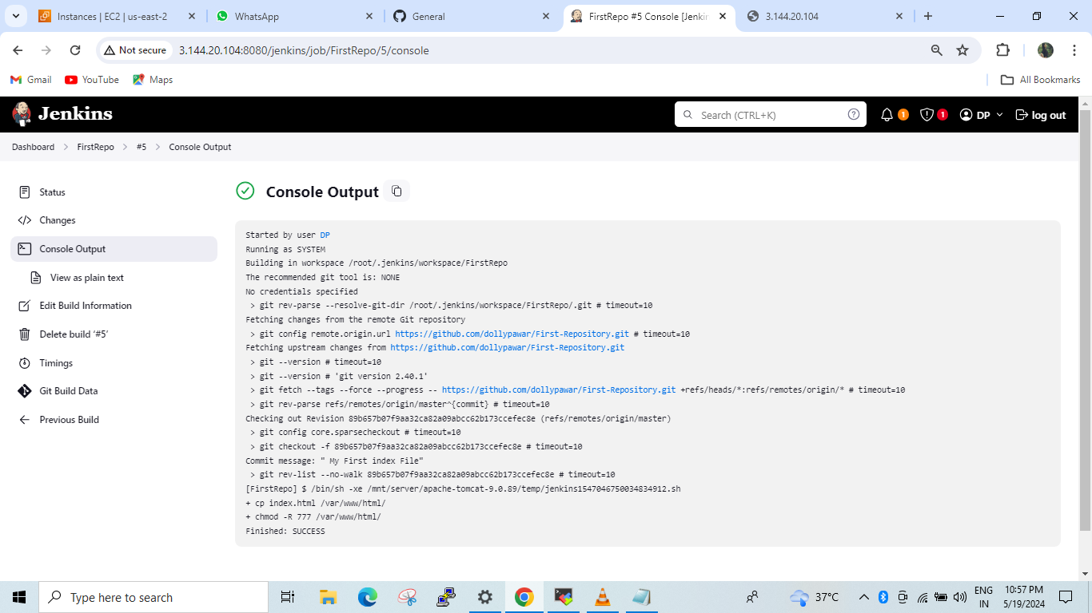

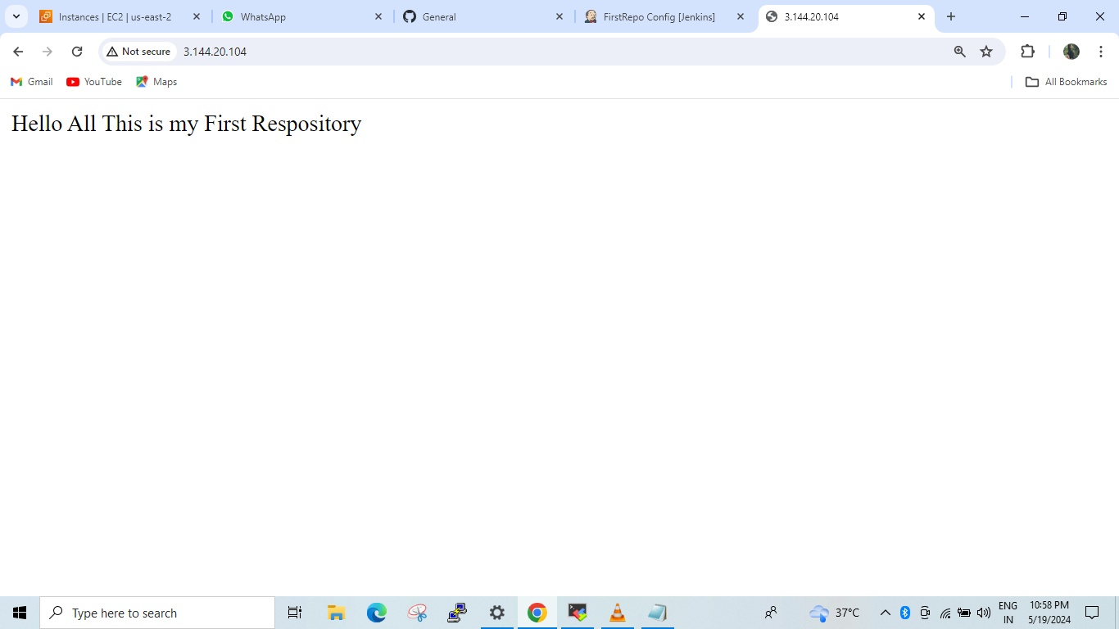

14>Screenshot of Console Output of JOB 2 and Browser displaying the content of JOB 2 index.html”

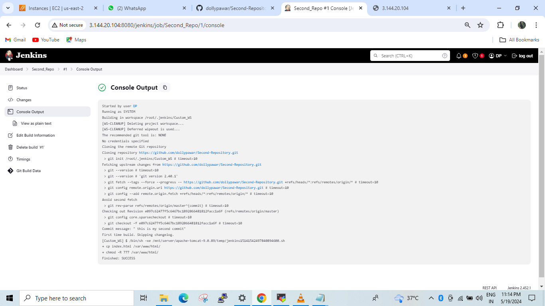

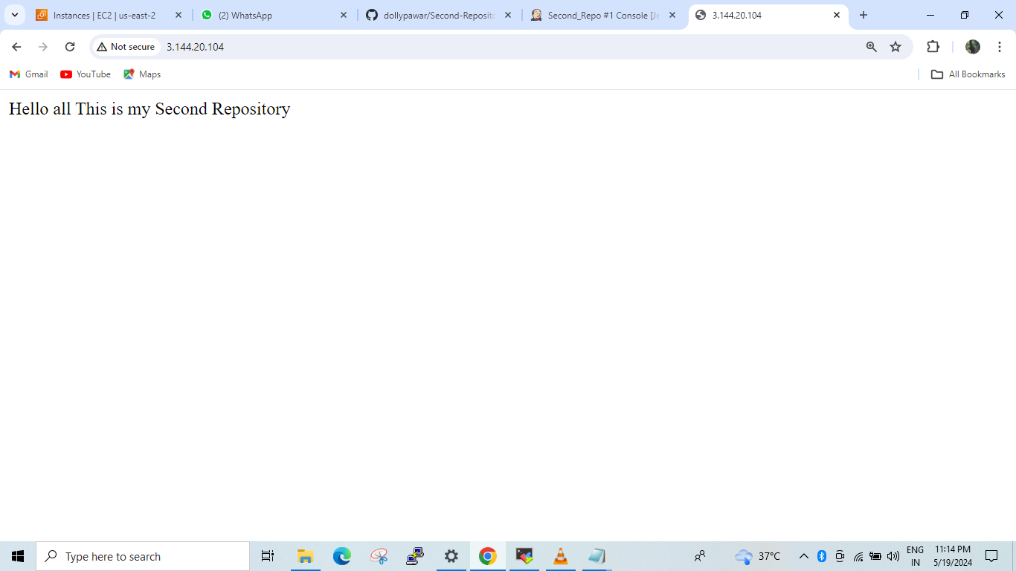

15>Screenshot of Console Output of JOB3 and Browser displaying the content of JOB 3 index.html”

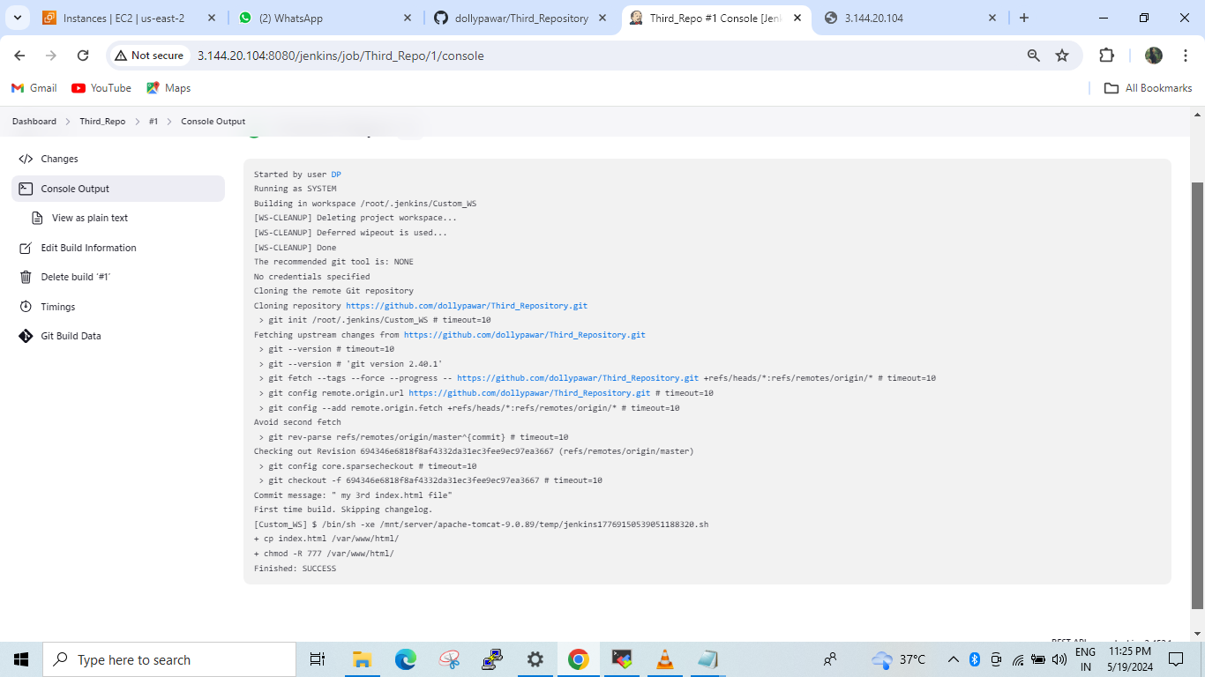

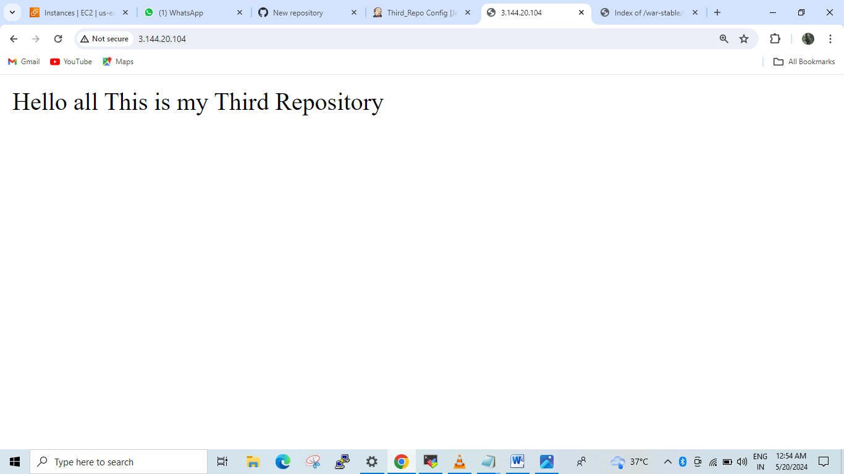

Here Our Assignment is completed.